Flight Controller v1.0 Test Instructions

Bellevue Satellite Club

Written by Dan Ruder, 1/20/2015, revised 3/3/2016

danruder@outlook.com

# Introduction

These instructions will help you verify that your flight controller operates correctly. Two procedures are needed to test the flight controller: an electrical test procedure to verify the board was assembled correctly and a programming test procedure to verify the board operates correctly. This document shows how to perform the electrical test; a separate document will describe how to complete the programming test.

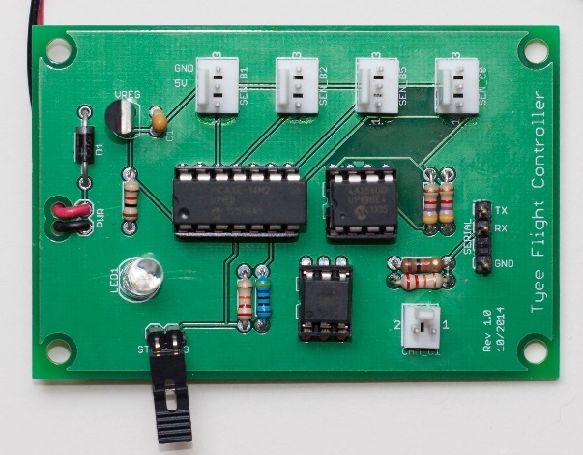

Figure 1 Fully-assembled and tested flight controller

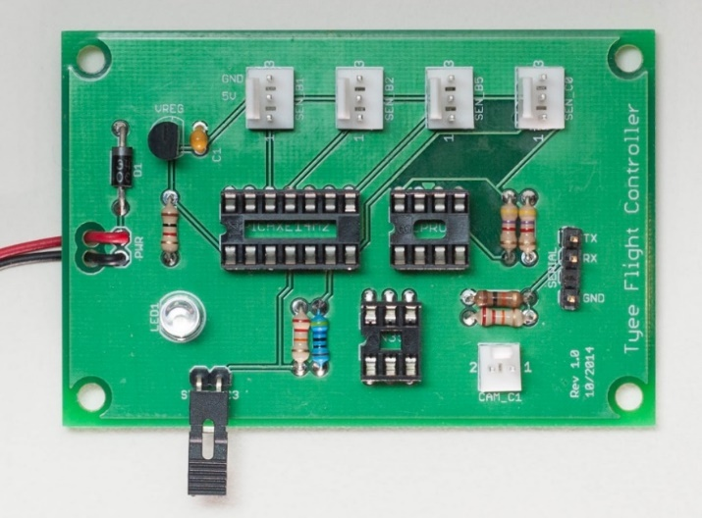

Figure 2 Assembled and ready for testing

# Tools & Materials

Digital Multimeter

Assembled flight controller

# General Instructions

* If you are not sure how to use a digital multimeter, please watch the following excellent tutorial series on YouTube:

[Multimeter Tutorial 1: Voltage Measurement](http://www.youtube.com/watch?v=ZBbgiBU96mM)

[Multimeter Tutorial 2: Current Measurement](http://www.youtube.com/watch?v=EVFkKBFJsZg)

[Multimeter Tutorial 3: Resistance and Continuity](http://www.youtube.com/watch?v=InJhgwmj2So)

# Electrical Test Procedure

The goal of this procedure is to ensure that the board was properly assembled by verifying every component is placed in its correct location and all soldering joints are well-made.

The flight controller board contains six circuits, shown in *Figure 3*, below. This procedure contains tests for each of these circuits.

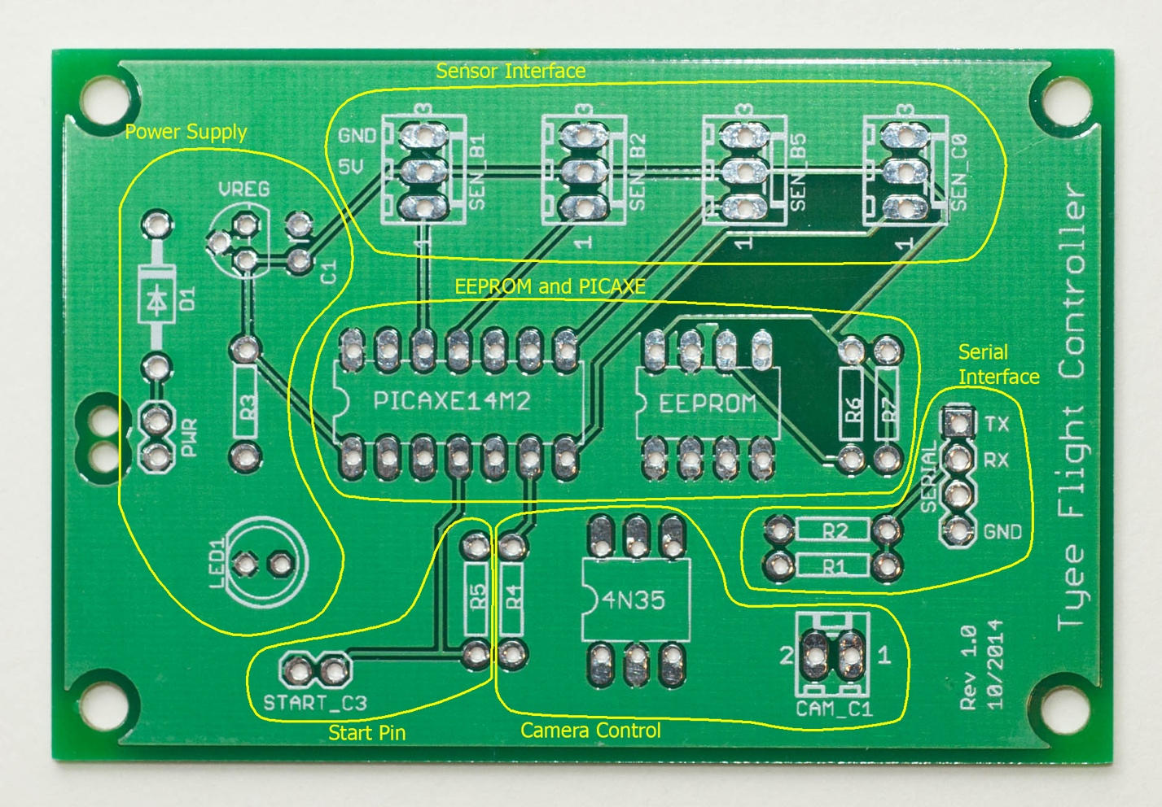

Figure Flight controller circuits

Before you begin, please make sure your board has been assembled and looks like the board in *Figure 4* below.

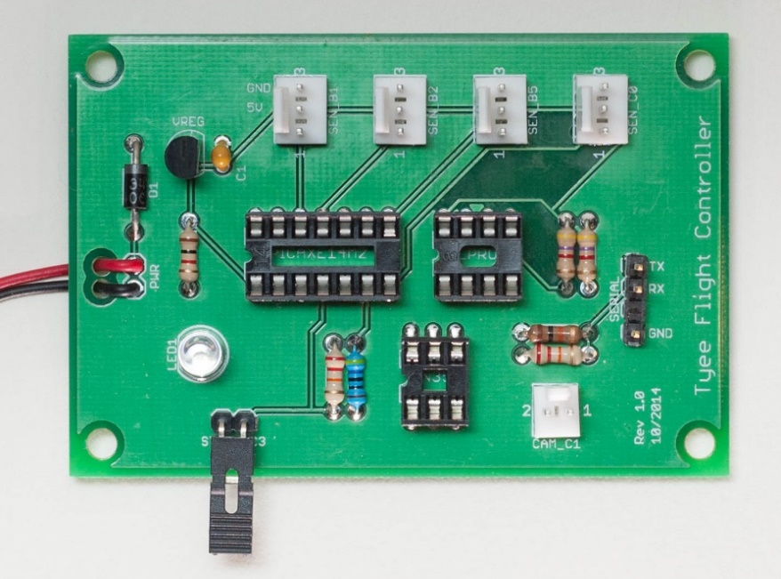

Figure Flight controller ready for the electrical test procedure

Each test will verify the *continuity* (that an electrical connection exists) between two points. To do this, place your digital multimeter into continuity test mode, then verify it is working correctly by touching the two probes together; when the probes touch, the multimeter should make a sound.

When you perform each step of the following tests, you will place one probe on one of the pins and the other probe on the other pin. The multimeter should make a sound if the circuit is properly soldered. If you do not hear a sound, check the orientation of the component and the solder joint.

*Figure 5* below shows all component labels and IC pinouts to help you identify the location of every component.

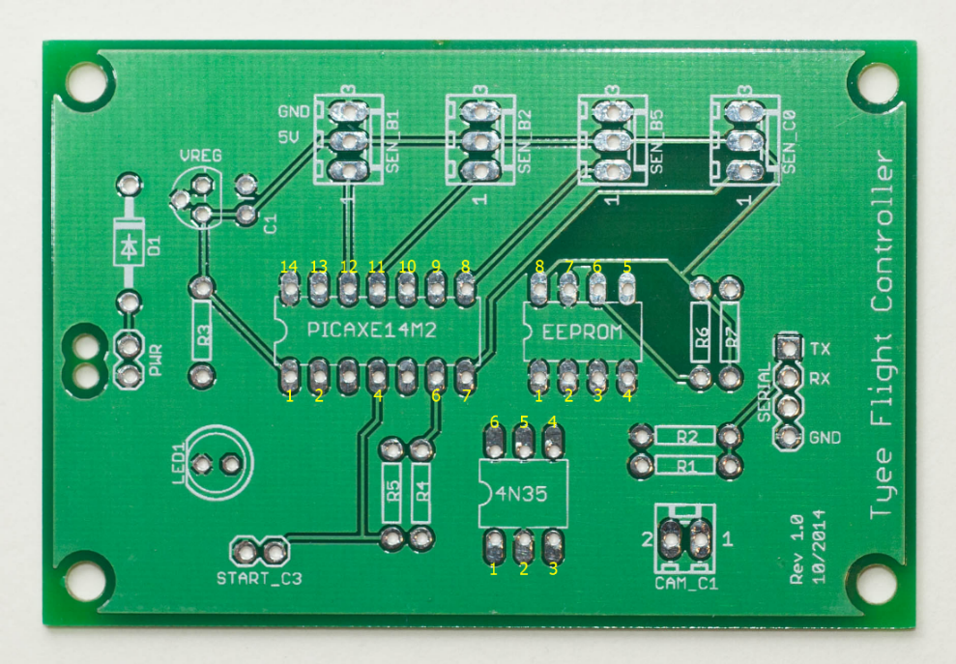

Figure Empty flight controller board showing all component labels; note yellow pin numbering for ICs

## Power Supply Circuit

Test the power circuit from the battery leads through the diode, voltage regulator, to the PICAXE and the LED. Use *Figure 6* to assist with this test.

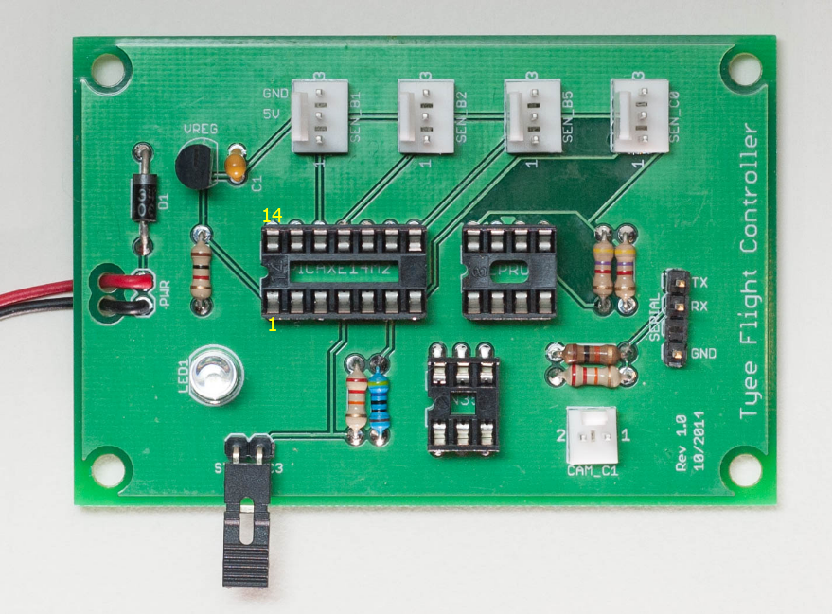

Figure Power Supply Circuit

### Steps

1. **Red power cable** to diode **D1**. If you don’t hear a sound, make sure the red battery lead is closest to diode D1, as in *Figure 6*.
2. Diode **D1** to **right leg of the voltage regulator** (closet to the *VREG* label).
3. **Center leg of the voltage regulator** to the **black power cable**.
4. **Left leg of the voltage regulator** (when looking at the flat side) to **PICAXE pin 1**.
5. **Black power cable** to **PICAXE pin 14**.
6. **Left leg of the voltage regulator** to the **left leg of capacitor** **C1** (closest to the *C1* label).
7. **Right leg of capacitor C1** to the **black power cable**.
8. Connect the battery and verify the LED illuminates. Then, disconnect the battery. If the LED does not illuminate, it may have been soldered into the board backwards. Check that the flat side of the LED faces toward the left edge of the board.
9. Verify that resistor R3 (between the LED and the voltage regulator) is 1K ohms (brown-black-red). Switch the multimeter to resistance mode, then touch one probe on each end of the resistor; the multimeter should read 1K ohms. Then switch the meter back to continuity mode.

## EEPROM and PICAXE Circuit

Test each of the pins in the 8-pin EEPROM IC socket; pins 1-4 are the address select lines and all should connect to ground; pins 5 and 6 are I2C bus lines that connect to corresponding I2C pins on the 14-pin PICAXE IC socket, pin 7 is the ground pin, and pin 8 is the 5V power pin. Use *Figure 7* to assist with this test.

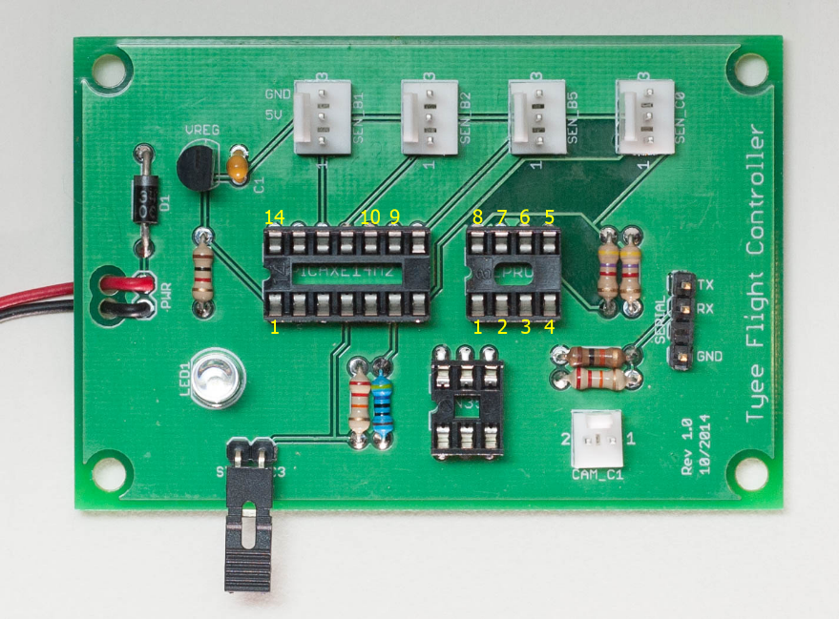

Figure 7 EEPROM & PICAXE Circuit

### Steps

1. **EEPROM pins 1 – 4** to **PICAXE pin 14** (GND – ground).
2. **EEPROM pin 5** to **PICAXE pin 9** (I2C SDA).
3. **EEPROM pin 6** to **PICAXE pin 10** (I2C SCL).
4. **EEPROM pin 7** to **PICAXE pin 14** (GND).
5. **EEPROM pin 8** to **PICAXE pin 1** (5V power).
6. Verify that resistors R6 and R7 (next to the 8-pin EEPROM socket) are 4.7K ohms (yellow-purple-red). Switch the multimeter to resistance mode, then touch one probe on each end of R6; the multimeter should read 4.7K ohms. Do the same for R7; the meter should read 4.7K ohms. Then switch the meter back to continuity mode.

## Serial Interface Circuit

Test the serial communication connection that is used to download programs and data between the flight controller and a PC. The serial connector is the three-pin black connector on the right side of the board. Note the labels next to each pin (TX, RX, GND). Use *Figure 8* to assist with this test.

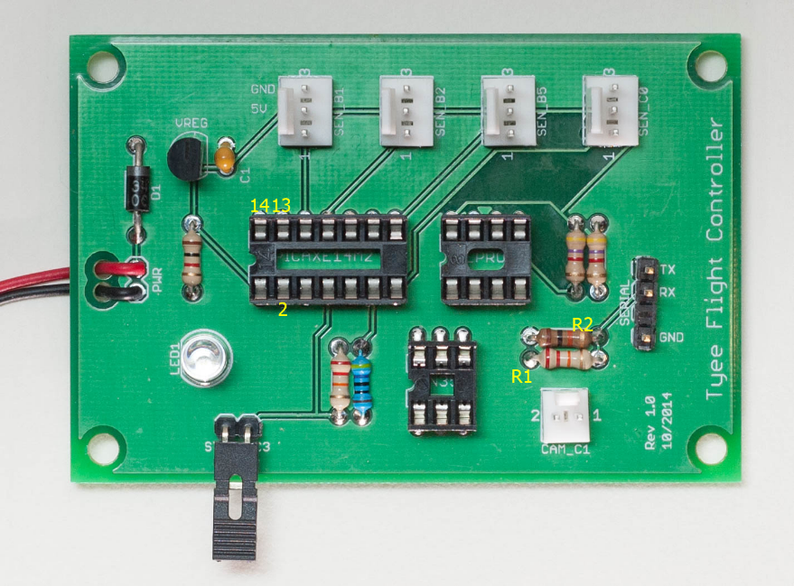

Figure 8 Serial Interface Circuit

### Steps

1. **GND pin** on black 3-pin serial connector to **PICAXE pin 14**.
2. **TX pin** on black 3-pin serial connector to **PICAXE pin 13**.
3. **RX pin** on black 3-pin serial connector to resistor **R2**.
4. Resistor **R1** (side closer to LED) to **PICAXE pin 2**.
5. Verify that resistor **R1** (next to the 2-pin white connector) is 22K ohms (red-red-orange). Switch the multimeter to resistance mode, then touch one probe on each end of the resistor; the multimeter should read 22K ohms.
6. Verify that resistor **R2** (next to R1) is 10K ohms (brown-black-orange). Then switch the meter back to continuity mode.

## Camera Control Circuit

Test the connections between the PICAXE and the 4N35 optoisolator and then between the 4N35 optoisolator and the white two-pin camera connector. Use *Figure 9* to assist with this test.

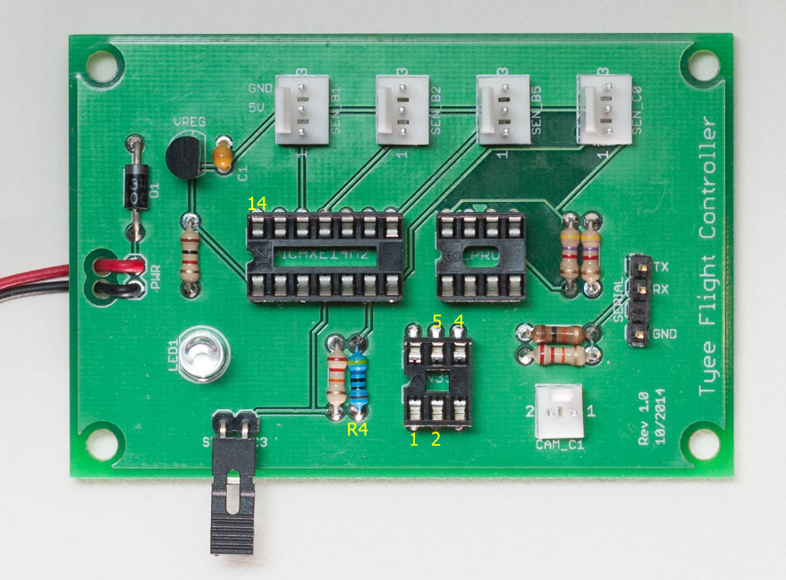

Figure 9 Camera Control Circuit

### Steps

1. **4N35 optoisolator pin 1** to resistor **R4** (side closest to edge of the board).
2. **4N35 optoisolator pin 2** to **PICAXE pin 14** (GND – ground).
3. **4N35 optoisolator pin 4** to camera connector **pin 2**.
4. **4N35 optoisolator pin 5** to camera connector **pin 1**.
5. Verify that resistor **R4** (next to the 6-pin optoisolator IC socket) is 470 ohms (yellow-purple-brown). Switch the multimeter to resistance mode, then touch one probe on each end of the resistor; the multimeter should read 470 ohms. Then switch the meter back to continuity mode.

## Sensor Interface Circuit

Test each of the three-pin white sensor connectors; all have the same pinouts (pin 1= input to the PICAXE IC socket, pin 2 = 5v power, and 3 = ground). Use *Figure 10* to assist with this test.

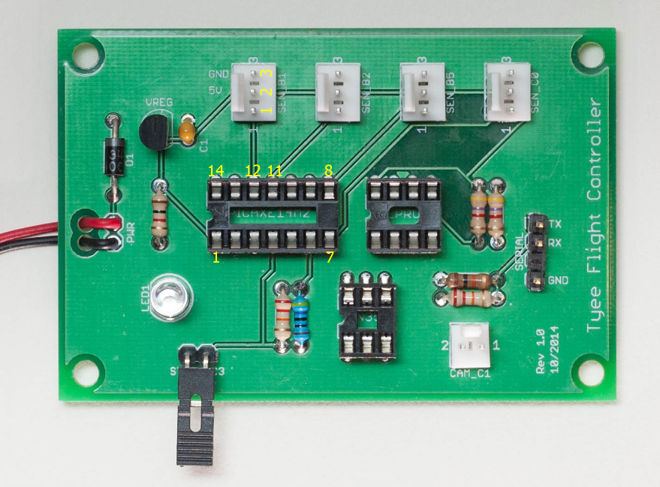

Figure 10 Sensor Interface Circuit

### Steps

1. **SEN_B1 pin 1** to **PICAXE pin 12**.
2. **SEN_B2 pin 1** to **PICAXE pin 11**.
3. **SEN_B5 pin 1** to **PICAXE pin 8**.
4. **SEN_C0 pin 1** to **PICAXE pin 7**.
5. **SEN_B1, B2, B5, C0 pins 2** (middle pins) to **PICAXE pin 1** (5v power).
6. **SEN_B1, B2, B5, C0 pins 3** to **PICAXE pin 14** (GND – ground).

## Start Pin Circuit

Test the connections between the PICAXE and the Start Pin while the black jumper pin is disconnected. (In the picture below, the jumper is connected.) Use *Figure 11* to assist with this test.

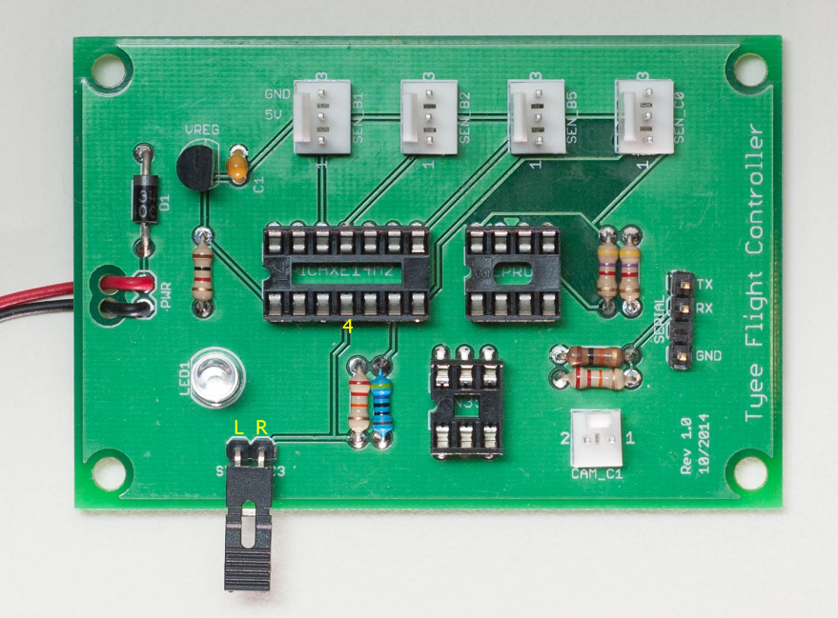

Figure 11 Start Pin Circuit

### Steps

1. **Right pin of Start connector** to **PICAXE pin 4**.
2. **Left pin of Start connector** to **black power cable**.
3. Verify that resistor **R5** (closest to the 2-pin start pin) is 22K ohms (red-red-orange). Switch the multimeter to resistance mode, then touch one probe on each end of the resistor; the multimeter should read 22K ohms. Then switch the meter back to continuity mode.

# Finishing Up

Once your flight controller has passed all of the electrical tests, return to the assembly instructions and insert the ICs (PICAXE, EEPROM, and optoisolator) according to the assembly instructions.

**CONGRATULATIONS! YOU HAVE FINISHED THE**

**ELECTRICAL TEST PROCEDURE!**